

Windows Workflow Foundation

Hands-On Lab

Lab Manual
Lab 08 – Transactional Behavior in Workflow in C#

Information in this document, including URL and other Internet Web site references, is subject to change without notice. This document supports a preliminary release of software that may be changed substantially prior to final commercial release, and is the proprietary information of Microsoft Corporation.

This document is for informational purposes only. MICROSOFT MAKES NO WARRANTIES, EITHER EXPRESS OR IMPLIED, AS TO THE INFORMATION IN THIS DOCUMENT.

The entire risk of the use or the results from the use of this document remains with the user. Complying with all applicable copyright laws is the responsibility of the user. Without limiting the rights under copyright, no part of this document may be reproduced, stored in or introduced into a retrieval system, or transmitted in any form or by any means (electronic, mechanical, photocopying, recording, or otherwise), or for any purpose, without the express written permission of Microsoft Corporation.

Microsoft may have patents, patent applications, trademarks, copyrights, or other intellectual property rights covering subject matter in this document. Except as expressly provided in any written license agreement from Microsoft, the furnishing of this document does not give you any license to these patents, trademarks, copyrights, or other intellectual property.

Unless otherwise noted, the example companies, organizations, products, domain names, e-mail addresses, logos, people, places and events depicted herein are fictitious, and no association with any real company, organization, product, domain name, email address, logo, person, place or event is intended or should be inferred.

© 2005 Microsoft Corporation. All rights reserved.

Microsoft, MS-DOS, Windows, Windows NT, Windows Server, SQL Server, Visual C# and Visual Studio are either registered trademarks or trademarks of Microsoft Corporation in the United States and/or other countries.

The names of actual companies and products mentioned herein may be the trademarks of their respective owners.
Contents
Lab 08: Transactional Behavior in Workflow 1
Lab Objective 1
Exercise 1 – Atomic Transactions in Workflows 1
Task 1 – Set up the solution 2
Task 2 – Create the Workflow 3
Task 3 – Run the Application 7
Exercise 2 – Compensation for Long-running Processes 9
Task 1 – Modify the Workflow Project 9
Task 2 - Test the application 14
Lab Summary 15

Lab 08: Transactional Behavior in Workflow
Estimated time to complete this lab: 40 minutes
The project files for this lab are in the c:\Windows Workflow Foundation\Labs\Lab08 folder.
This lab will familiarize the reader with atomic transactions, exceptions and compensation as used in workflow. We will be communicating with a database and deliberately throwing exceptions to demonstrate the rollback process of transactions.

Lab Objective
The objective of this lab is to demonstrate exceptions, transactions and compensation features of Windows Workflow Foundation.
After completing this lab, you will be able to:
- Use atomic and long-running transactions with compensating behavior in the context of a workflow application
- Manage exceptions within a workflow

Scenario
A bank connects to a database crediting and debiting accounts. If money is withdrawn from one account then placed in another account and an exception occurs, such as being overdrawn, both the credit the debit must be rolled back correctly.

Exercise 1 – Atomic Transactions in Workflows
In this exercise, you will learn how to use atomic transactions in a workflow. Atomic transactions exhibit ACID (Atomicity, Consistency, Isolation and Durability) properties that can enlist in transactions (say in the context of SQL databases). You will create a workflow to model moving money from one bank account to a second bank account. The workflow will consist of a sequence of activities. In the first activity money is withdrawn from bank account A. In the second activity money is deposited in bank account B. In the third activity an exception is thrown. All three activities are wrapped in a TransactionScope; this is functionally equivalent to a .Net 2.0 System.Transactions.TransactionScope. The two code activities perform the money transfer operation by using ADO.NET to access a SQL Server database that you create as part of the exercise.

You will observe that the database activities are rolled back at the end of the workflow and you will observe that when the exception activity is disabled, the database transaction does not get rolled back.

Task 1 – Set up the solution

- It is required that you have either SQL Server or SQL Server Express installed on your machine to continue this exercise. The database scripts provided work with the default SQL Server Express (SQLExpress) database named instance. Using other database instance names requires editing of the scripts.
- Copy the Exercise1 directory from C:\Windows Workflow Foundation\Labs\Lab08\Resources\ to C:\Windows Workflow Foundation\Labs\Lab08\
- Open a command window and change your directory to C:\Windows Workflow Foundation\Labs\Lab08\Exercise1
- Run setupdatabase.bat script to create the Bank database we will use for this exercise. The script first creates a database with a name “Bank” (if the database is already created, it drops it first). The Bank database will have two tables, with two columns each. We will be recording banking transactions on those tables.

ChequeAccount |  | SavingsAccount
ChequeAccountId |  | SavingsAccountId
Balance |  | Balance

- Since we will be working with transactions, we will need a persistence mechanism to persist the workflow instance as part of the transaction. Please run the script SetupPersistenceService.bat in the same folder to setup the SqlPersistenceService service’s store. The database name used is WorkflowStore. The service is added by default in your host application program.cs.
- Open the solution file AtomicTransactionsWorkflow.sln under C:\Windows Workflow Foundation\Labs\Lab08\Exercise1\AtomicTransactionsWorkflow\
- Right click on the AtomicTransactionWorkflow project and select Add | New Item
- Choose Application Configuration File and click the Add button
- Between the <configuration> tags add the following xml:
<configuration>
<appSettings>
<add key="connectionString" value="Integrated Security=SSPI; Persist Security Info=False;Initial Catalog=WorkflowStore; Data Source=.\SQLExpress" />
</appSettings>
</configuration>

- This connection string is specifically for a default SQL Express install. If you have a different instance name or are using SQL Server it will be modify the connection string to reflect this. If you are running a non-standard configuration it will be necessary to change the Source to point at the database you are using.

Task 2 – Create the Workflow

- Double click on Workflow1.cs from the Solution Explorer to show the workflow design surface.
- Drag a TransactionScope activity from the Toolbox and drop it onto the workflow surface.
- Drag a Code activity from the Toolbox and drop it into the box marked “Drop Activities Here” inside the TransactionScope activity.
- In the Properties window for codeActivity1 activity set the properties as follows:
- (Name) – Debit
- ExecuteCode – select DebitCodeHandler from the dropdown list.
- Your workflow should look like this:

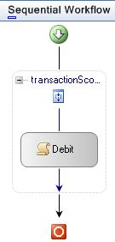

- Go back to workflow design view and drag a Code activity from the Toolbox, and drop it underneath the Debit activity within the TransactionScope activity.
- In the Properties Window for codeActivity1 activity set the Properties as follows:
- (Name) - Credit
- ExecuteCode – select CreditCodeHandler from the dropdown list.
- From the Toolbox, drag a Throw activity and drop it inside the TransactionScope activity underneath the Credit activity.
- In the Properties window for throwActivity1 set the Properties as follows:
- Fault – Click the ellipses button. In the property binding dialog, click the Bind to existing member tab, select exception and click OK.

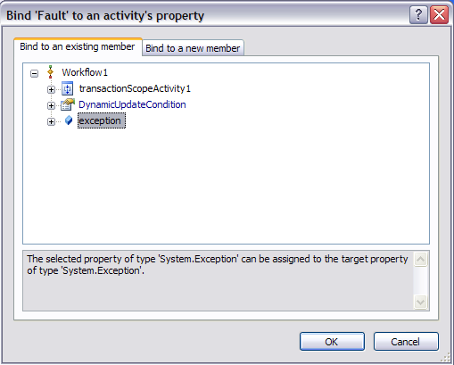

- FaultType – Click on the ellipses button. In the “Browse and select a .Net Type” dialog, browse to find mscorlib.System.Exception. Then click OK.
- Select View Fault Handlers by clicking the third tab at the base of the workflow designer.

.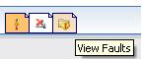

Add a FaultHandler to the workflow by dragging a FaultHandler activity from the Toolbox, and dropping it into the upper-most box marked “Drop FaultHandlerActivity Here”.
- In the Properties window for faultHandlerActivity1 set the Properties as follows:
- FaultType – Click on the ellipses button. In the “Browse and select a .Net Type” dialog, browse to find mscorlib.System.Exception. Then click OK.
- From the Toolbox, drag a Code activity and drop it into the area marked “Drop Activities Here” for faultHandlerActivity1.

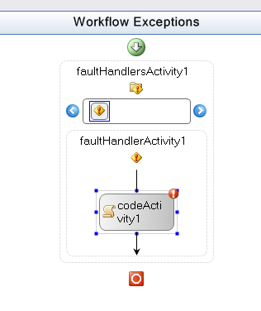
- In the Properties window for codeAcitivty1 in faultHandlerActivity1 set the Properties as follows:
- (Name) – WorkflowExceptionHandler
- ExecuteCode – select OnException from the dropdown list.
- Go back to the SequentialWorkflow view of the workflow by clicking on the first tab at the base of the workflow designer.
- Drag a Code activity from the Toolbox and drop it underneath the transactionScopeActivity1.
- In the Properties window for codeActivity1 set the Properties as follows:
- (Name) – FinishWorkflow
- ExecuteCode – select OnFinishWorkflow from the dropdown list
- Your workflow should look like this at the end of this step:
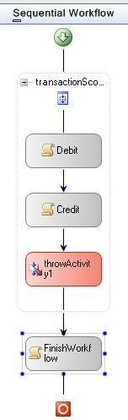

Task 3 – Run the Application

- Open a command window and change directory to “C:\Windows Workflow Foundation\Labs\Lab08\Exercise1”
- Run the batch file “dumptables.bat”. This script dumps the contents of ChequeAccount and SavingsAcount tables. It should display the following before the workflow is run:

Checking balance

---------------------

100.0000

1 row affected)

Savings balance

---------------------

100.0000
- Build and run the solution by pressing CTRL + F5.
- You should see the following.

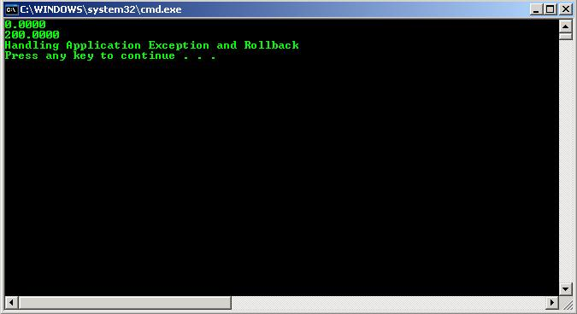

- Press the ENTER key twice.
- Run the batch file “dumptables.bat” again. You should see that the tables have not been modified since the exception caused a rollback because the TransactionScopeActivity is atomic.
- Now go back to Workflow1.cs
- Select the throwActivity1 activity and change the enabled property to “false”.
- Go to your Command window and run the script setupdatabase.bat to clean your database.
- Run the application again by pressing CTRL+F5 in Visual Studio 2005
- You can observe that the rollback of the tables does not occur now by running “dumptables.bat” after the application completes.

Exercise 2 – Compensation for Long-running Processes
In this exercise, you will learn how to author compensation in Microsoft Windows Workflow Foundation. Compensation applies to completed transactions (Atomic or Long Running) and is the process of logically undoing the completed transactions (either Atomic or Long Running) in case of any business exceptions. For example this could be reversing a purchase order if there are insufficient funds on a credit card to complete the order.

Task 1 – Modify the Workflow Project

- Open the Visual Studio 2005 solution you have created for exercise 1 by navigating to C:\Windows Workflow Foundation\Labs\Lab08\Exercise1\AtomicTransactionsWorkflow if it is not already open.
- Open the workflow Workflow1.cs by double clicking it in the Solution Explorer
- To use the compensation capabilities of Windows Workflow Foundation we need to replace our TransactionScopeActivity transactionScopeActivity1 with a CompensatableTransactionScopeActivity. Select the 3 activities Debit, Credit and throwActivity1 by clicking on each while holding down the CTRL key. Right click on Debit and select Copy from the context menu.
- Select transactionScopeActivity1 and delete it by either selected Delete from the context menu or by pressing the Delete key.
- Drag a CompensatableTransactionScopeActivity from the Toolbox and drop it on the workflow surface just above the FinishWorkflow activity.
- Right click within compensatableTransactionScopeActivity and select Paste from the context menu to add our 3 activities we copied earlier, Debit, Credit and throwActivity1.

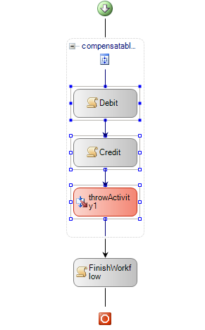

- Right click on the compensatableTransactionScopeActivity1 on the designer and select ‘View Compensation Handler” from the context menu. The designer view should look like this:

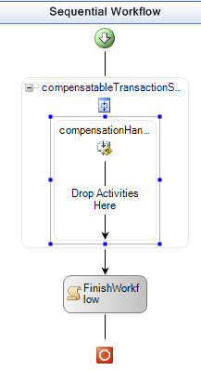
- Add a Code activity onto the area labeled “Drop Activities Here”. In the Properties window for codeActivity1 set the Properties as follows:
- (Name) – compensateOperation
- ExecuteCode – select OnCompensation from the dropdown list.

Your designer view should look like this:

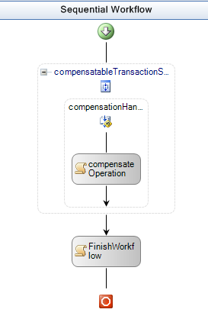

- Go the CompensatableTransactionScope view of compensatableTransactionScopeActivity1 by right clicking on compensatableTransactionScopeActivity1 and selecting “View CompensatableTransactionScope.”
- Move throwActivity1 in the workflow so that it occurs after the compensatableTransactionScopeActivity1 activity completes and set the Enabled property to True. Your workflow should look like this:

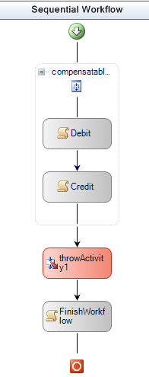

- Switch to View Faults by clicking the third tab on the bottom of the design surface and add a Compensate activity to the exception handler just after the WorkflowExceptionHandler activity.
- Set the Properties of the compensate1 activity as follows from the drop down list
- TargetActivityName: compensatableTransactionScopeActivity1

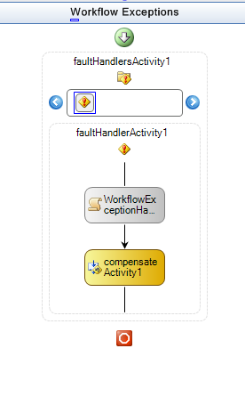

Task 2 - Test the application

- Open a command window and navigate to C:\Windows Workflow Foundation\Labs\Lab08\Exercise1. Run the script “setupdatabase.bat” to refresh the database.
- Build and run the application by pressing CTRL+F5 in Visual Studio 2005.
- Notice that even though the transaction was committed as seen in the output, the compensation operation logically restores the tables to the original values. This can be verified by running the dumptables.bat script again to display the contents of the tables. You should be able to see the transaction has been reversed by the values displayed.

Lab Summary
Our objective in this lab was to introduce the concepts and topics related with transactions. We had two exercises:
- The first exercise uses a TransactionScopeActivity. It has three activities within the TransactionScopeActivity, one for a debit operation, the other for a credit operation and the last one is simply there to initiate a rollback by throwing an exception.
- The second exercise builds on the first. The throw activity is also taken out of the CompensatableTransactionScopeActivity and added to the workflow after the CompensatableTransactionScopeActivity for demonstrating that the compensation logic added to the CompensatableTransactionScopeActivity can be triggered as a part of the business logic from within the workflow with a compensation activity. The workflow starts, and enters the CompensatableTransactionScopeActivity (which contains the credit and debit operations) and exits the CompensatableTransactionScopeActivity. An exception is thrown after the CompensatableTransactionScopeActivity and the compensation is invoked as a part of the exception handler of the workflow. The compensation logic just reverses the operations done during the CompensatableTransactionScopeActivity.

